Communication Subsystem of Weather Monitoring System

Justin Adams, Basit Baloch, Anna-Noelle Beech, Hasan Merzai

**Abstract**

Climate change presents significant challenges globally, affecting various environmental aspects. In New York State, understanding how climate change impacts microclimates—localized weather conditions differing from their surroundings—is crucial for effective mitigation and adaptation strategies. As climate change intensifies, these microclimate variations become more pronounced, prompting a deeper investigation requested by The New York State Department of Environmental Conservation. They aim to better grasp climate change's impact on microclimates within the state to mitigate adverse effects and implement appropriate preventative measures.

To expedite microclimate research, we propose an easily deployable, accurate, and cost-efficient weather monitoring system tailored for businesses and homeowners. This system aims to enhance data collection capabilities, enabling researchers to gather a wider range of data and address potential gaps in prior work. Key features include offline storage integration for data continuity during outages and reliance on an external display application for user interface, ensuring accessibility.

By implementing this system, we aim to contribute to a clearer understanding of microclimates in New York State and their role in climate change, supporting efforts to adapt and mitigate its effects.

**The Problem**

Problem Statement

The New York State Department of Environmental Conservation needs a better understanding of the impact of climate change on microclimates within New York State so that they can mitigate adverse effects and take appropriate preventative measures.

Problem Introduction

Climate change is an ongoing issue in today’s world. Effects include rising sea levels, warmer temperatures, and an increase in natural disasters. A microclimate is a region whose landscape may be colder, warmer, drier, or wetter than the rest of its surrounding area. Climate change can alter or amplify these properties and is an area that requires further research to better understand. We propose to design an efficient and cost-effective home/business weather monitoring system to aid in data collection for research.

Creating this system will allow us to attain a wider range of data and help accelerate the current study of microclimates. The project's desired impact is to reduce the adverse effects of climate change in microclimates, allowing researchers to attain a better understanding of climate change in general. Potential benefits of this system include real-time accurate climate predictions, better response times to changes in weather conditions for microclimates, and potential further education in environmental change. This project can also enable the development of new solutions/understandings of climate change, leading to safer and greener environments.

**Inspiration**

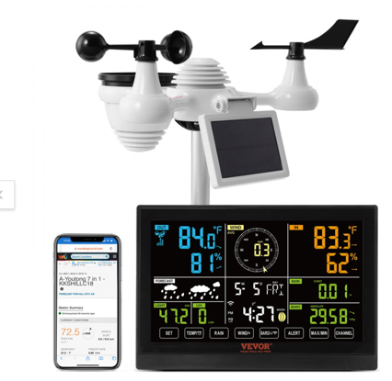 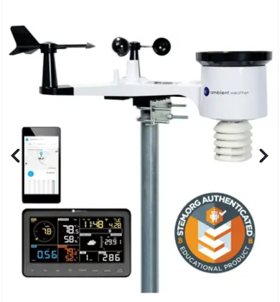

*Figure 1.* VEVOR 7-in-1 Wi-Fi Weather  *Figure2.*  Tempest Weather System *Figure 3.*  Ambient Weather System

Drawing inspiration from the Vevor 7-in-1, Ambient, and Tempest Weather System, our weather monitoring technology merges the strengths of these systems. By integrating multiple sensors, Wi-Fi connectivity, and solar power, our solution offers comprehensive tracking capabilities.

Innovatively, we enhance user experience by replacing the traditional touchscreen interface with remote smartphone control, reducing costs without sacrificing functionality. Inspired by the Tempest Weather System, we adopt a modular approach, utilizing separate units for indoor and outdoor use. This design facilitates RF communication, enabling extended data collection capabilities.

Addressing common shortcomings in existing systems, our solution ensures continuous access to data through offline storage, even during Wi-Fi outages. Combining cost-effectiveness with advanced functionality, our system promises reliable performance under any condition.

Subsequently, we will showcase how our innovative system addresses these shortcomings, offering a more efficient and effective weather monitoring solution for users across various domains.

**System Requirements**

Use Case Diagram

*Figure 4:* Use case diagram that assess the problem statement

Functional Requirements

• Accuracy: The system should be able to record precise weather data with an accuracy of 75-80%, any data deemed to be inaccurate/inconsistent should be disregarded to reduce the influence of outliers. This can be done by comparing the results to weather data in a weather app.

• Collect and Share Data: The system should be able to collect accurate data and upload it to an accessible location by the NYDEC.

• Calibration: All subsystems should be able to be calibrated by an engineer or within the system itself by the user.

Non-Functional Requirements

•Durability: The system needs to be durable enough to withstand harsh environmental conditions.

• Replication: The system documentation should be thorough and in-depth, allowing other engineers to replicate and implement our design.

• Ease of Deployment: The system should be easy to install, with minimal setup on the user end.

• Safety: System components should be sealed properly, any possibility of water leaking into the system can result in a fire hazard.

Design Constraints

• Low Cost $150: The budget is $150; we are limited to a certain quality of components in this budget.

• Time: This system needs to be completed before April 22nd. Time constraints will be affected by the time to receive parts/equipment, or problems with troubleshooting the system.

• Resources: Available resources are another constraint. As of now, everyone has a basic Arduino electrical kit. Other parts may have to be ordered online or bought at a store. Not all parts may come from the US, some international (hope to avoid).

Subsystem Requirements: Communication

Focusing more on the communication subsystem, more specific requirements are met to ensure that the weather monitoring system can collect and share data between units and NYDEC.

* **Range:** The communication system should have a range of about ~0.5 miles to transfer data between outdoor and indoor units
* **Power Consumption:** The communication system (outdoor unit) should maintain low power consumption under 50mW to ensure continuous operation, aligning with the system's commitment to sustainable operation and prolonged utilization. The indoor unit is connected to wall power, so power is not a constraint.
* **Wireless Communication:** Utilize RF communication for wireless connectivity between outdoor and indoor units and Wi-Fi to the NYDEC server for the indoor unit, ensuring seamless data transfer.
* **Time:** The system must collect and send live data every minute to ensure relatively real time data transfer and low power consumption (the MCU goes into low power mode when not transmitting data.

There is also an additional non-functional requirement:

* Licensing: The system should operate without any licensing requirements, simplifying deployment logistics, adhering to regulatory standards, and enhancing user-friendliness. This ensures hassle-free usage for users with no need for additional licenses.

**System Design**

Design Overview & Justification

**High-Level Description:**

The weather monitoring system consists of two units, an Indoor Unit and an Outdoor Unit, both equipped with various sensors (moisture, wind, temperature, gas). The user interacts with the system through a dedicated mobile app. Communication between the units is facilitated wirelessly using radio frequency (RF). Data is stored in offline storage, parallel to cloud storage through Wi-Fi. Power is sourced from a solar panel for the Outdoor Unit and wall power for the Indoor Unit. Data is transferred through Wi-Fi to the NYDEC. The housing is designed using 3D printing technology, optimizing sensor placement for enhanced functionality and aesthetic appeal.

**Alternative Designs Considered:**

*Combined Unit with NYDEC Communication:*

The combine unit would consist of the same outdoor unit that collects data, but instead of having an additional indoor interface to display the data, the data would directly display on the app. In the separate design with two units, it had an outdoor unit that only collects, an indoor unit to display information also, and maybe potentially an app. The combine unit cuts out the physical receiving aspect of the display interface

**Pros:** Simplifies the system into a single unit; utilizes New York State Department of Environmental Conservation (NYDEC) communication protocols.

**Cons:** May compromise modularity and flexibility; potential limitations with NYDEC standards.

*3D Printed Housing Design:*

There would be 3D printed housing for both outdoor and indoor units. Both units will be customized to the most compact size need with ventilation for sensors.

**Pros:** Optimizes sensor placement; enhances aesthetic appeal; cost-effective internal components; broader accessibility.

**Cons:** Need prior CAD experience to design and potential complexity in assembly.

*App & Indoor Display: Users can have the option of two interfaces. Both the indoor and app display will use a WebSocket to connect to users Wi-Fi and display sensor readings.*

**Pros:** Provides a dual interface for user interaction; indoor display for immediate information.

**Cons:** Increased power consumption; potential redundancy with the mobile app.

Subsystem decision matrices

|  |  |  |  |  |
| --- | --- | --- | --- | --- |
| **Microcontroller** | | | | |
| **Criteria** | **Weight (1-5)** | **ESP32-S3** | **ATmega328p** | **Raspberry Pi Pico W** |
| Cost-effectiveness | 5 | 3 | 5 | 1 |
| WI-FI | 5 | 5 | 1 | 5 |
| Number of GPIO pins | 3 | 5 | 2 | 5 |
| Power Efficiency | 4 | 4 | 2 | 5 |
| Core count (dual/single) | 2 | 5 | 3 | 5 |
|  | | | | |
| Total | | 81 | 50 | 75 |

*Figure 5.* Decision Matrix for Microcontroller

|  |  |  |  |  |
| --- | --- | --- | --- | --- |
| **Data Transmission Module** | | | | |
| **Criteria** | **Weight (1-5)** | **NRF24L01+PA+NLA** | **HC-12** | **LoRa sx1278** |
| Range | 5 | 4 | 3 | 5 |
| Transmission speed | 4 | 5 | 3 | 2 |
| Power efficiency | 4 | 5 | 5 | 5 |
| Cost-effectiveness | 5 | 4 | 5 | 3 |
| Simplicity | 2 | 3 | 5 | 1 |
|  | | | | |
| Total | | 86 | 82 | 72 |

*Figure 6.* Decision Matrix for Data Transmission Module

In the context of a weather station project, where accurate data collection and transmission are paramount, the selection of appropriate microcontroller and data transmission components plays a pivotal role. The ESP32-S3 microcontroller emerges as a standout choice, offering Wi-Fi capability that facilitates seamless internet connectivity for real-time data transmission and remote monitoring. With its dual-core processing capability and generous GPIO pin count, the ESP32-S3 provides the necessary computational power and versatility to interface with a wide array of sensors and peripherals commonly employed in weather stations.

Complementing the ESP32-S3, the NRF24L01+PA radio frequency transmission module presents an ideal solution for achieving efficient communication over moderate to long distances. This module's high transmission speed makes it particularly well-suited for transmitting weather data reliably. Moreover, the module’s simplicity and affordability enhance its appeal, especially in weather station projects with budget constraints. By leveraging the ESP32-S3's Wi-Fi connectivity alongside the NRF24L01+'s efficient data transmission capabilities, the weather station system can ensure reliable operation and streamlined data transmission processes, facilitating accurate weather monitoring and analysis.

Black Box Diagram

Overall System:

*Figure 7.* Overall system Blackbox diagram

The system relies on inputs such as weather data collected by sensors, a power source, and calibration. These inputs are essential for the generation of the output, which is weather data analyzed by NYDEC.

Subsystem:

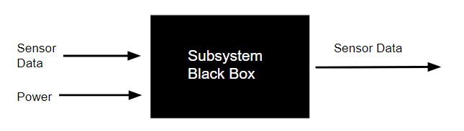

*Figure 8*. Communication Subsystem Blackbox Diagram

The sub system relies on inputs such as power and the date from the senses. These inputs are essential for the output, which is the sensor data being sent to the home unit.

Logical Design Overall System

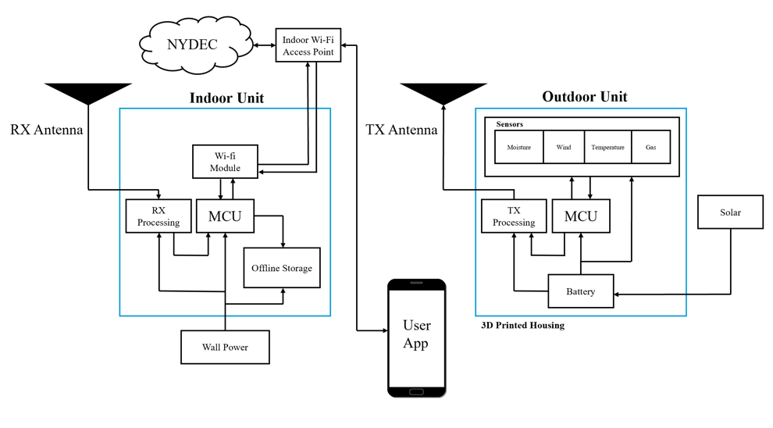

*Figure 9.* Overall system Logical Design for both outdoor and indoor units

The logical design displays two units, an indoor and an outdoor unit. The outdoor unit is kept as lightweight as possible, with only the essentials for capturing and transmitting data. The outdoor unit is powered by a lightweight battery, which is charged during the day through a solar panel. Raw data is captured through the sensors and processed by the MCU. The MCU then sends out the processed data to a radio processing circuit, which sends the data out through the RF channel with the TX Antenna. The indoor unit receives the information through the RF channel and processes it again through the receiving radio processing circuit. The MCU receives this data and processes it into digital signals, sending it to offline storage while also uploading it to the NYDEC database through the Wi-Fi module. The user can access the processed data through the app, or physical media (offline storage).

Subsystem Logical Design Overall System

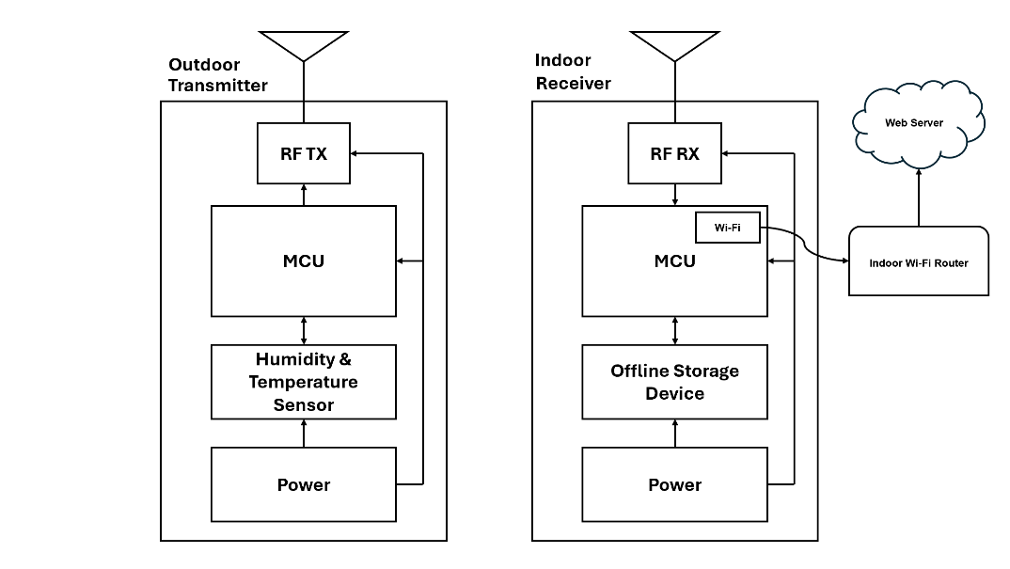

*Figure 10.*  Communcation Subsystem Logical Design

The logical design for our sub-system contains two separate modules, the sub-system for the indoor unit, and the sub-system for the outdoor unit. The two systems communicate through the RF spectrum, with the receiving end taking the information and storing it into offline storage. In addition, the indoor unit also uploads the live data to a web server for access by the NYDEC and the user. The two modules are powered by the power sub-system which is abstracted generically. The RF transmission will be tested by reading a basic humidity and temperature sensor at the outdoor unit and sent over RF to the receiving indoor unit.

Wireframe Model

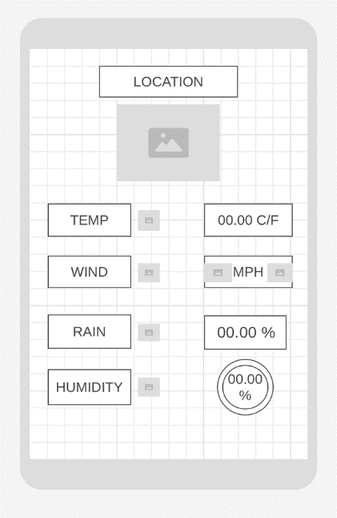

*Figure 11.* User interface via phone application/website

We have basic visuals that show the temperature, wind speed, rain and humidity percentages. There is only one screen due to the data being displayed, but the user doesn’t interact with the app other than reading it.

Physical Design

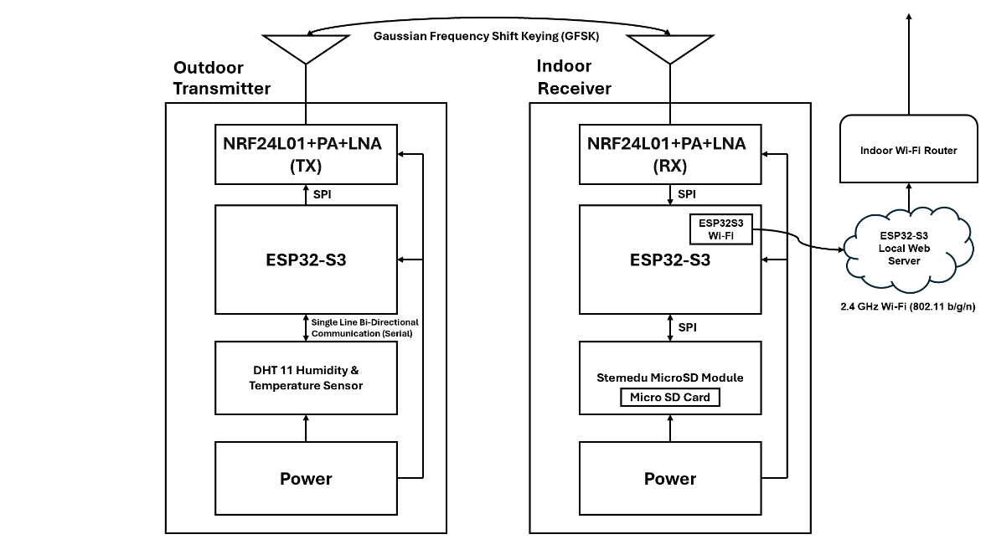

*Figure 12.* Communication Subsystem Physical design with indoor and outdoor units

The system is centered around an ESP32-S3 microcontroller unit (MCU) for both modules. It is a low-power MCU with integrated Wi-Fi and Bluetooth capabilities, featuring 45 programmable GPIO pins and 4 Serial Peripheral Interfaces. The MCU operates in sleep mode on the transmission end when not transmitting to reduce power consumption.

The data is transmitted through the NRF24L01+PA+LNA radio frequency modules, which communicate with the MCU through the allocated Serial Peripheral Interfaces. These modules have a range of 800-1100m and operate in the 2.4GHz ISM band, requiring no license. They use Gaussian Frequency Shift Keying to send data.

On the transmitting side, a DHT11 humidity and temperature sensor communicate serially through a single bi-directional communication data port. This differs from normal SPI in that the data is transmitted through one wire.

On the receiving end, there is a Stenedu MicroSD Module containing a backup offline microSD card for power outage scenarios. The MCU writes received data into the MicroSD card through the SPI protocol. Additionally, data is uploaded to the MCU's local web server. Devices connected to the indoor Wi-Fi router can view current temperature and humidity readings via the MCU's IP address.

Due to time constraints, a server-based approach could not be implemented. Currently, the local access point fulfills the intended behavior.

Bill of Materials

*Figure 13*. Bill of Materials needed for communication subsystem

Above are all the materials needed to build the communication system.

**Semester Planning**

Gannt Chart

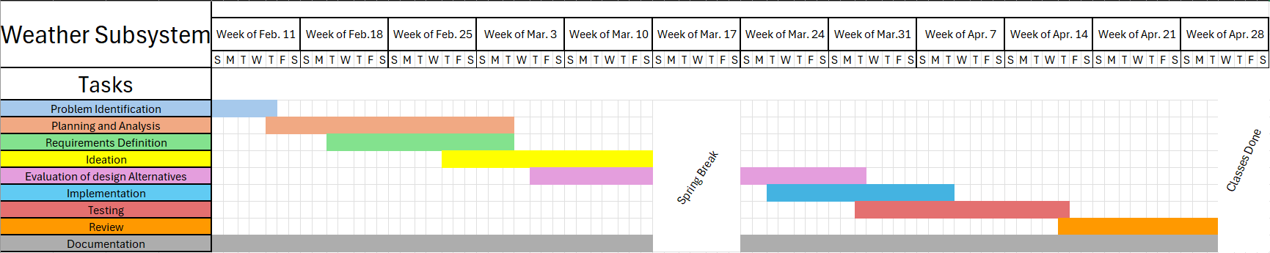*Figure 14*. Gaant Chart to show project timeline

**Testing Analysis**

**Testing Procedure**

Testing the communication range between the indoor receiver unit and the outdoor transceiver unit involves a systematic procedure aimed at determining the maximum distance over which the two units can reliably exchange data under real-world conditions. To conduct this test, both units are taken outside, with the indoor receiver unit positioned in a stationary location and the outdoor transceiver unit mounted on the dashboard of a vehicle. The vehicle is then driven away from the stationery receiver, periodically stopping at predefined intervals to assess data transfer. Throughout the test, data transfer success or failure is recorded. By analyzing the collected data, we can identify the threshold distance at which communication consistently fails. This threshold distance serves as a crucial metric for determining the effective communication range between the two units.

*Figure 15.* Communication Testing over different distances.

Following the comprehensive testing procedure outlined, we have determined that the threshold distance for reliable communication between the indoor receiver unit and the outdoor transceiver unit is approximately 0.425 miles. This distance aligns with 85% of our specified requirement for transmission distance. Based on this finding, we can confidently conclude that the transmission distance requirement has been successfully met.

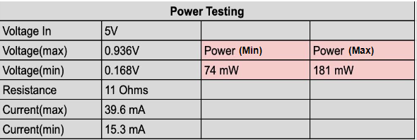

*Figure 16.* Power Consumption Testing

To measure the power consumption of the outdoor unit, we took 2 measurements, one with the MCU asleep, and one with the MCU actively transferring data to the indoor unit. We utilized a small 10-ohm resistor in series with our power supply, measuring the voltage across the resistor and using Ohm’s law to measure the current draw. We used this current draw and multiplied it by the supply voltage minus the voltage drop across the resistor to find the total power consumption for each mode. The results are displayed in Figure 16. We were unable to meet our power requirement of 50mW. Future improvements include implementing MOSFET based switching to reduce current drawn from the RF module and sensors when asleep, alongside a better linear voltage regulator that has small quiescent current than the on-board voltage regulator.

**Sources**

NASA. “The Effects of Climate Change.” Global Climate Change: Vital Signs of the Planet, NASA, 27 Sept. 2023, climate.nasa.gov/effects/.

“Microclimates.” Veganic Agriculture Network, goveganic.net/how-to-grow/approaches-to-veganic/permaculture/microclimates/.

“IoT in Weather Monitoring Systems and Forecasting for Agriculture.” Blog, 15 Mar. 2023, tech-stack.com/blog/iot-in-weather-monitoring-systems-and-forecasting-for-agriculture/#:~:text=Collecting%20and%20analyzing%20weather%20data. Accessed 15 Mar. 2024.

“Discover VEVOR Weather Station Home | Shop to Stay Secure.” *Www.vevor.com*, www.vevor.com/weather-station-c_12074/. Accessed 21 Apr. 2024.

“Amazon.com: Tempest Weather System with Built-in Wind Meter, Rain Gauge, and Accurate Weather Forecasts, Wireless, App and Alexa Enabled : Patio, Lawn & Garden.” *Www.amazon.com*, www.amazon.com/dp/B0868WY7NY. Accessed 21 Apr. 2024.

“Ambient Weather WS-2902 Smart Wifi Weather Station with WiFi Remote Monitoring & Alerts.” *Ambient Weather*, ambientweather.com/ws-2902-smart-weather-station?utm_id=go_cmp-17798158262_adg-_ad-__dev-c_ext-_prd-WS-2902D_mca-147779820_sig-CjwKCAjwz42xBhB9EiwA48pT7zNSjSaNZT6LD5yCm4bFD2K_CV-. Accessed 21 Apr. 2024.